LOCAL HOMELESSNESS ACTION PLAN
AND APPLICATION TEMPLATE

HOMELESS HOUSING, ASSISTANCE AND PREVENTION PROGRAM
ROUND 4 (HHAP-4)

Revised October 21, 2022

Purpose of this Template
The California Interagency Council on Homelessness (Cal ICH) is providing this Local Homelessness Action Plan and Application Template as optional for use by jurisdictions seeking the disbursement of remaining funding under Round 4 of the Homeless Housing, Assistance and Prevention Program (HHAP-4). This Template is intended to support the development and submission of information required for approval by Cal ICH as required in AB 140 (Health & Safety Code § 50218.6, et seq.), collectively referred to as a Local Homelessness Action Plan.

This Template is also intended to support the streamlined presentation of application information to be agendized at a local governing board meeting and available for public comment as stated in Health and Safety Code Section 50220.8(b)(4). Statute does not require local governing boards to take action on or formally adopt the agendized content, however, local governments may choose to do so.

- PART I: LANDSCAPE ANALYSIS OF NEEDS, DEMOGRAPHICS, AND FUNDING
This section provides a format for providing the following required information:
- A local landscape analysis that assesses the current number of people experiencing homelessness and existing programs and funding which address homelessness.
- Identification of the number of individuals and families served, including demographic information and intervention types provided, and demographic subpopulations that are underserved relative to their proportion of individuals experiencing homelessness.
- Identification of funds, currently being used, and budgeted to be used, to provide housing and homelessness-related services to persons experiencing homelessness or at imminent risk of homelessness, how this funding serves subpopulations, and types of interventions funded.
- PART II: OUTCOME GOALS AND STRATEGIES FOR ACHIEVING THOSE GOALS
This section of the Template provides applicants with a format for providing Outcome Goals, and strategies for achieving those goals, across the following performance measures:
- Reducing the number of persons experiencing homelessness.
- Reducing the number of persons who become newly homeless each year.
- Increasing the number of people exiting homelessness into permanent housing.
- Reducing the length of time persons remain homeless.
- Reducing the number of persons who return to homelessness within two years after exiting homelessness to permanent housing.
- Increasing successful placements from street outreach.
- Trackable data goals related to the Outcome Goals as they apply to underserved populations and populations disproportionately impacted by homelessness.
- PART III: APPLICATION NARRATIVE RESPONSES
This section includes the required narrative responses for the HHAP-4 application. These narrative responses are to provide additional information on regional coordination, capacity building, and equity related efforts in alignment with local action plan goals and strategies.

- PART IV: HHAP 4 FUNDING PLAN AND STRATEGIC INTENT NARRATIVE
This section provides a format for describing the specific allowable activities to be supported with HHAP-4 funds and for describing the strategic intent for investing HHAP-4 resources into those activities and the alignment of those investments with other funding investments.

APPLICANT INFORMATION

List the eligible applicant(s) submitting this application for HHAP-4 funding below and check the corresponding box to indicate whether the applicant(s) is/are applying individually or jointly.

Eligible Applicant(s) and Individual or Joint Designation

This application represents ☐ an individual ☐ a joint application for HHAP-4 funding on behalf of the following eligible applicant jurisdiction(s):

Eligible Applicant Name
Choose an item.
Choose an item.
Choose an item.
Choose an item.
Choose an item.
Choose an item.
Choose an item.

Funds awarded based on this application will be administered by the following Administrative Entity:

Administrative Entity Information
Administrative Entity: | Click or tap here to enter text.
Contact Person: | Click or tap here to enter text.
Title: | Click or tap here to enter text.
Contact Phone Number: | Click or tap here to enter text.
Contact Email Address: | Click or tap here to enter text.

Agreement to Participate in HDIS and HMIS [50220.8(b)(3)(C)]
By submitting this application, we agree to participate in a statewide Homeless Data Integration System, and to enter individuals served by this funding into the local Homeless Management Information System, in accordance with local protocols.
PART I: LANDSCAPE ANALYSIS OF NEEDS, DEMOGRAPHICS, AND FUNDING

- Landscape Analysis of Needs and Demographics [50220.8(b)(1)(A)]
Please use Table 1 in the HHAP-4 Data Tables Template to provide key data regarding people experiencing homelessness in your jurisdiction. An example can be seen below.

The information provided in Table 1 should reflect the most current Point In Time Count data available or your most current and accurate way of estimating the number and demographics of people experiencing homelessness on the day that you are preparing the data, which could rely on utilizing: data from the Homeless Data Integration System (HDIS); point-in-time count (PIT) data; Continuum of Care Housing Inventory Count (HIC) data; longitudinal systems analysis (LSA); HUD’s Stella tools; as well as any recently conducted local needs assessments, analyses, or other data sources.

TABLE 1 (EXAMPLE ONLY)
No changes from HHAP-3
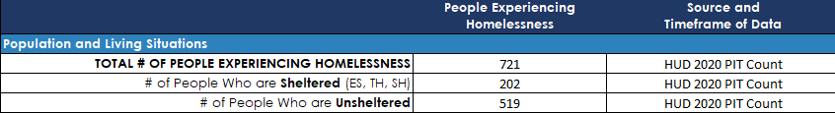

- Landscape Analysis of People Being Served [50220.8(b)(1)(B)]
Please use TABLE 2 in the HHAP-4 Data Tables Template to report the number of individuals and families served. The data provided within Table 2 should represent your most current and accurate way of estimating the annual number and demographics of people participating within or being served by the different intervention types, including subpopulations that are underserved relative to their proportion of individuals experiencing homelessness in the jurisdiction. It is important to note that intervention types are not mutually exclusive, and individuals and households may be counted in multiple categories.

Grantees are encouraged to utilize existing documentation, including but not limited to: data from the Homeless Data Integration System (HDIS); point-in-time count (PIT) data; Continuum of Care Housing Inventory Count (HIC) data; longitudinal systems analysis (LSA); HUD’s Stella tools; as well as data from the CoC’s local HMIS and any recently conducted needs assessments, analyses, or other data sources. An example can be seen below.

Table 2 uses the following abbreviations:
- PSH – Permanent Supportive Housing
- RRH – Rapid Rehousing
- TH – Transitional Housing
- IH / ES – Interim Housing or Emergency Shelter
- DIV – Diversion Services and Assistance
- HP – Homelessness Prevention Services and Assistance
- O/R – Outreach and Engagement Services

TABLE 2 (EXAMPLE ONLY):
No changes from HHAP-3

- Landscape Analysis of State, Federal, and Local Funding [50220.8(b)(1)(C)]
Please use TABLE 3 in the HHAP-4 Data Tables Template to identify and document all budgeted funds for homelessness-related services and housing opportunities. Please include state, federal and local funds for current and future fiscal years that are dedicated to homeless specific resources (e.g., CoC, ESG, HHAP). Also please include homelessness dedicated vouchers, including Housing Choice Vouchers (HCVs), Emergency Housing Vouchers (EHVs), Family Unification Program (FUP) or HUD-VA Supportive Housing (HUD-VASH) vouchers. For those fund sources supporting voucher-based programs, indicate your best estimate of the dollar value of those vouchers in your community rather than the number of vouchers. Please include resources related to affordable housing financing dedicated to homeless units, including Homekey, NPLH and any other homeless specific capital resources. Please exclude resources related to funds applied for but not awarded, and vouchers, capital awards, and any other resources not specifically dedicated to people experiencing homelessness in your community.

This information should not focus on funding only being expended directly alongside HHAP funding, but should document the full range of funding being used within your jurisdiction’s efforts to prevent and end homelessness while identifying the housing and services programming that is supported with those funds.

The “Total Amount” should include the total funds invested into homelessness interventions from that source of funding in each of the designated fiscal year(s). For the current Fiscal Year only, please also select all intervention types that apply and provide a brief program description, indicating services provided and subpopulations served.

Applicants should add as many rows as necessary to identify and document the full range of funding being used within your jurisdiction’s efforts to prevent and end homelessness. An example can be referenced below.

Table 3: Landscape Analysis of State, Federal, and Local Funding (EXAMPLE ONLY)
REVISED since HHAP-3

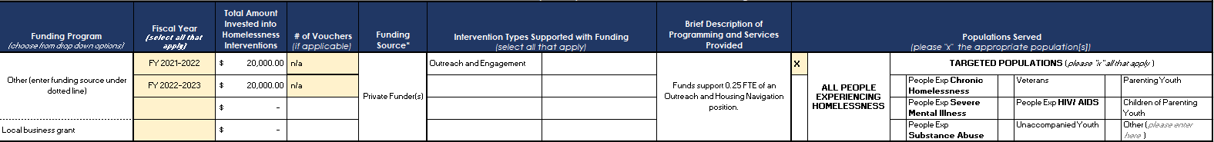
PART II: OUTCOME GOALS AND STRATEGIES FOR ACHIEVING THOSE GOALS
HHAP-4 applicant jurisdictions are required to establish Outcome Goals for the progress that they will make in preventing and reducing homelessness over the three-year period of July 1, 2022 through June 30, 2025, informed by the findings from the local landscape analysis information completed above and the jurisdiction’s base system performance measures from the 2021 calendar year data in the Homeless Data Integration System.

Please note that these Outcomes Goals are not intended to be related to HHAP-4-funded activities alone, but rather are intended to represent jurisdictional or system-wide goals for making progress on preventing and ending homelessness through the implementation of the full range of federal, state, and local funding sources and through many other kinds of strategies and activities.

HHAP-4 applicant jurisdictions must set goals for each of the following Outcome Goals:
- Reducing the number of persons experiencing homelessness.
- Reducing the number of persons who become newly homeless each year.
- Increasing the number of people exiting homelessness into permanent housing.
- Reducing the length of time persons remain homeless.
- Reducing the number of persons who return to homelessness within two years after exiting homelessness to permanent housing.
- Increasing successful placements from street outreach.

Further, applicant jurisdictions are required to establish Homeless Management Information System trackable data goals related to each of the Outcome Goals as they apply to underserved populations and populations disproportionately impacted by homelessness.

Cal ICH will provide applicant jurisdictions with baseline data on each of these measures. Grantees, in partnership with Cal ICH, will develop outcome goals established from the baseline data provided. Information on how these outcomes are being measured will be provided with the baseline data. Cal ICH will also provide grantees with quarterly HDIS data in order to monitor progress on outcome goals.

- Outcome Goals [50220.8(b)(2)(A)]
Please use TABLE 4 in the HHAP-4 Data Tables Template to develop outcome goals. An example has been provided below.

Note: For the Goal Statement applicants should only change the information in brackets, do not change any other wording in the goal statement except the information in brackets. Please use the Goal Narrative section to explain key factors that helped determine the Outcome Goals being set, especially if the goals being set are not aligned with the directional intent of the Outcome Goals, e.g., if the goal is to reduce the rate of growth in the number of people who become homeless for the first time rather than the actual number of people who become homeless for the first time.

Table 4: Outcome Goals (EXAMPLE ONLY)
REVISED since HHAP-3

Outcome Goal #2: Reducing the number of persons who become homeless for the first time.
Goal Statement:
By the end of the performance period, HDIS data for the [name of CoC] will show [#] total people become homeless for the first time annually, representing [#] [fewer or more] people and a [%] [reduction or increase] from the baseline.
Goal Narrative:
[explain reasoning for setting this goal, especially if the goals being set are not aligned with the directional intent of the Outcome Goals]
Baseline Data:  Annual Estimate of # of people who become homeless for the first time | Outcome Goals July 1, 2022 - June 30, 2025
 | Change in # of People | Change as % of Baseline | Target Annual Estimate of # of people who become homeless for the time
2,250 people annually*  *Actual baseline to be provided by Cal ICH from HDIS: can use local data as placeholder in the meantime | 450 fewer people annually | 20% reduction | 1800 people annually
Describe Your Related Goals for
Underserved Populations and Populations Disproportionately Impacted by Homelessness
Describe any underserved and/ or disproportionately impacted population(s) that your community will especially focus on related to this Outcome Goal and how this focus has been informed by data in your landscape assessment: |  | Describe the trackable data goal(s) related to this Outcome Goal:
Analysis of local data shows that while Black people represent 10% of the population in our CoC’s geographic area, Black people represent approximately 42% of individuals who become homeless for the first time each year and approximately 44% of families with children who become homeless for the first time each year have a Black head of household. |  | Reduce the number of Black individuals and families with children with Black heads of household who become homeless for the first time annually by 30%, exceeding our overall 20% reduction in the number of people who become homeless for the first time annually.
- Strategies for Achieving Outcome Goals
In this section, applicants must describe actionable strategies they will implement to meet the Outcome Goals identified above. Because individual strategies to address homelessness usually contribute to meeting more than one desired outcome, applicants are asked to identify the strategy and then to indicate all the outcome goals for which the strategy will help drive progress and to indicate if it will help drive progress on goals for underserved populations and populations disproportionately impacted by homelessness.

Please use TABLE 5 in the HHAP-4 Data Tables Template to document the strategies that will be implemented. An example has been provided below.

Applicants are expected to identify and describe local strategies that include but extend beyond the current and planned use of HHAP funding to be inclusive of, but not limited to, strategies for:
- Strategic uses of other sources of funding;
- Increasing investments into, or otherwise scaling up, specific interventions or program types;
- Strengthening the quality or performance of housing and/or services programs;
- Improving access to supportive services and/or physical health and behavioral health services;
- Expanding and strengthening cross-system partnerships and/or collaborative planning;
- Improving data quality, data systems, and/or data analyses to better inform decision-making;
- Building the capacity of homelessness response system to utilize resources, implement best practices, and/or achieve outcomes;
- Strengthening systemic efforts and processes, such as coordinated entry and assessment processes, landlord engagement efforts, housing navigation strategies, and other systemic improvements;
- Expanding and strengthening partnerships with people with lived expertise;
- Reaching underserved and historically marginalized communities and populations; and
- Other equity-focused strategies.

In describing these strategies, applicants are strongly encouraged to use and/or adapt content from:
- Current local strategic plans or actions plans for preventing and ending homelessness;
- Prior HHAP applications and reporting;
- Recent applications under HUD’s Continuum of Care program; and/or
- Other relevant local policy documents or plans.

Table 5: Strategies to Achieve Outcome Goals (EXAMPLE ONLY)
REVISED since HHAP-3

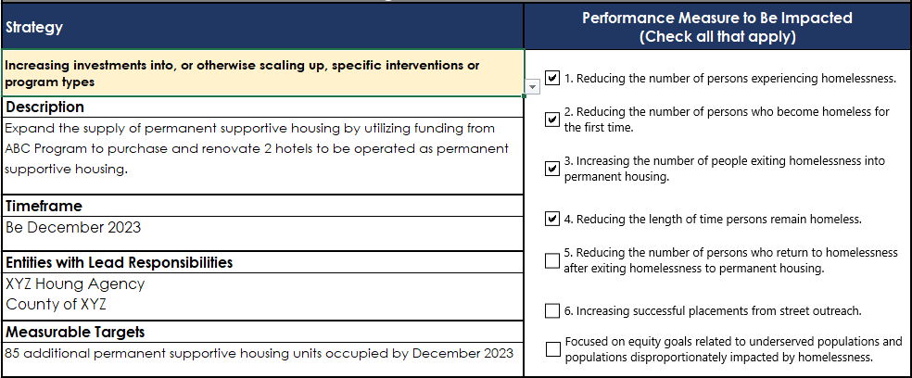

PART III. NARRATIVE RESPONSES
In preparing these narrative responses, applicants are strongly encouraged to use and/or adapt content from: their current local strategic plans or actions plans for preventing and ending homelessness; prior HHAP applications and reporting; their most recent applications under HUD’s Continuum of Care program; and/or other relevant local policy documents or plans.
- [50220.8(b)(3)(D)] My jurisdiction (e.g., City, County, CoC) collaborated with other overlapping jurisdictions to develop the strategies and goals related to HHAP-4.
☐ Yes ☐No ☐ Other (please explain Click or tap here to enter text. )
- [50220.8(b)(3)(D)] My jurisdiction (e.g., City, County, CoC) consulted with each of the following entities to determine how HHAP-4 funds would be used:
Public agencies (governmental entities) | ☐ Yes | ☐ No | ☐ Other (please explain)  Click or tap here to enter text.
Private sector partners (philanthropy, local businesses, CBOs etc) | ☐ Yes | ☐ No | ☐ Other (please explain)  Click or tap here to enter text.
Service providers (direct service providers, outreach, shelter providers, etc) | ☐ Yes | ☐ No | ☐ Other (please explain)  Click or tap here to enter text.
Local governing boards | ☐ Yes | ☐ No | ☐ Other (please explain)  Click or tap here to enter text.
People with lived experience | ☐ Yes | ☐ No | ☐ Other (please explain)  Click or tap here to enter text.
Other (please specify)  Click or tap here to enter text. | ☐ Yes | ☐ No | ☐ Other (please explain)  Click or tap here to enter text.

  - Please describe your most notable coordination and collaborative processes with these entities:
Click or tap here to enter text.
- [50220.8(b)(3)(B) and 50220.8(b)(3)(E)] My jurisdiction (e.g., City, County, CoC) is partnering or plans to use HHAP funding to increase partnership with:

People with lived experience | ☐ Yes, formal partnering  ☐ CURRENT  ☐ PLANNED  ☐ HHAP Funds Support This Partnership | ☐ Yes, informal partnering  ☐ CURRENT  ☐ PLANNED  ☐ HHAP Funds Support This Partnership | ☐ No | ☐ Other (please explain)  Click or tap here to enter text.
Social services (CalFresh, Medi-cal, CalWORKs, SSI, VA Benefits, etc) | ☐ Yes, formal partnering  ☐ CURRENT  ☐ PLANNED  ☐ HHAP Funds Support This Partnership | ☐ Yes, informal partnering  ☐ CURRENT  ☐ PLANNED  ☐ HHAP Funds Support This Partnership | ☐ No | ☐ Other (please explain)  Click or tap here to enter text.
Justice entities | ☐ Yes, formal partnering  ☐ CURRENT  ☐ PLANNED  ☐ HHAP Funds Support This Partnership | ☐ Yes, informal partnering  ☐ CURRENT  ☐ PLANNED  ☐ HHAP Funds Support This Partnership | ☐ No | ☐ Other (please explain)  Click or tap here to enter text.
Workforce system | ☐ Yes, formal partnering  ☐ CURRENT  ☐ PLANNED  ☐ HHAP Funds Support This Partnership | ☐ Yes, informal partnering  ☐ CURRENT  ☐ PLANNED  ☐ HHAP Funds Support This Partnership | ☐ No | ☐ Other (please explain)  Click or tap here to enter text.
Services for older adults | ☐ Yes, formal partnering  ☐ CURRENT  ☐ PLANNED  ☐ HHAP Funds Support This Partnership | ☐ Yes, informal partnering  ☐ CURRENT  ☐ PLANNED  ☐ HHAP Funds Support This Partnership | ☐ No | ☐ Other (please explain)  Click or tap here to enter text.
Services for people with disabilities | ☐ Yes, formal partnering  ☐ CURRENT  ☐ PLANNED  ☐ HHAP Funds Support This Partnership | ☐ Yes, informal partnering  ☐ CURRENT  ☐ PLANNED  ☐ HHAP Funds Support This Partnership | ☐ No | ☐ Other (please explain)  Click or tap here to enter text.
Child welfare system | ☐ Yes, formal partnering  ☐ CURRENT  ☐ PLANNED  ☐ HHAP Funds Support This Partnership | ☐ Yes, informal partnering  ☐ CURRENT  ☐ PLANNED  ☐ HHAP Funds Support This Partnership | ☐ No | ☐ Other (please explain)  Click or tap here to enter text.
Education system | ☐ Yes, formal partnering  ☐ CURRENT  ☐ PLANNED  ☐ HHAP Funds Support This Partnership | ☐ Yes, informal partnering  ☐ CURRENT  ☐ PLANNED  ☐ HHAP Funds Support This Partnership | ☐ No | ☐ Other (please explain)  Click or tap here to enter text.
Local Homeless Coordinated Entry System | ☐ Yes, formal partnering  ☐ CURRENT  ☐ PLANNED  ☐ HHAP Funds Support This Partnership | ☐ Yes, informal partnering  ☐ CURRENT  ☐ PLANNED  ☐ HHAP Funds Support This Partnership | ☐ No | ☐ Other (please explain)  Click or tap here to enter text.
Other (specify _________________) | ☐ Yes, formal partnering  ☐ CURRENT  ☐ PLANNED  ☐ HHAP Funds Support This Partnership | ☐ Yes, informal partnering  ☐ CURRENT  ☐ PLANNED  ☐ HHAP Funds Support This Partnership | ☐ No | ☐ Other (please explain)  Click or tap here to enter text.

  - Please describe your most notable partnerships with these groups (e.g. MOUs, shared funding, data sharing agreements, service coordination, etc.)
Click or tap here to enter text.
- [50220.8(b)(3)(B) and 50220.8(b)(3)(E)] My jurisdiction (e.g., City, County, CoC) is strengthening its partnership, strategies, and resources across:
Managed care plans and resources (such as the Housing and Homelessness Incentive Program [HHIP]) | ☐ Yes | ☐ No | ☐ Data Sharing Agreement Established | ☐ Other (please explain)  Click or tap here to enter text.
Physical and behavioral health care systems and resources | ☐ Yes | ☐ No | ☐ Data Sharing Agreement Established | ☐ Other (please explain)  Click or tap here to enter text.
Public health system and resources | ☐ Yes | ☐ No | ☐ Data Sharing Agreement Established | ☐ Other (please explain)  Click or tap here to enter text.

  - Please describe your most notable coordination, planning, and/or sharing of data/information that is occurring within these partnerships.
Click or tap here to enter text.
- [50220.8(b)(3)(F)] Please select what actions your jurisdiction will take to ensure racial/ethnic/gender groups that are overrepresented among residents experiencing homelessness have equitable access to housing and services. Note: These actions should be aligned with the equity-focused Outcome Goals and related strategies described in previous Parts, but should not need to be limited to those strategies.
☐ Disaggregating administrative data for use in decision making processes
☐ Modifying procurement processes
☐ Ensuring those with lived experience have a role in program design, strategy development, and oversight
☐ Developing workgroups and hosting training related to advancing equity
☐ Other, please describe:

- Please describe the most notable specific actions the jurisdiction will take regarding equity for racial/ethnic/gender groups.
Click or tap here to enter text.

- [50220.8(b)(3)(G)] My jurisdiction (e.g., City, County, CoC) has specific strategies to prevent exits to homelessness from institutional settings in partnership with the following mainstream systems:

Physical and behavioral health care systems and managed care plan organizations | ☐ Yes, formal partnering | ☐ Yes, informal partnering | ☐ Yes, leveraging funding | ☐ No | ☐ Other (please explain)  Click or tap here to enter text.
Public health system | ☐ Yes, formal partnering | ☐ Yes, informal partnering | ☐ Yes, leveraging funding | ☐ No | ☐ Other (please explain)  Click or tap here to enter text.
Criminal legal system and system for supporting re-entry from incarceration | ☐ Yes, formal partnering | ☐ Yes, informal partnering | ☐ Yes, leveraging funding | ☐ No | ☐ Other (please explain)  Click or tap here to enter text.
Child welfare system | ☐ Yes, formal partnering | ☐ Yes, informal partnering | ☐ Yes, leveraging funding | ☐ No | ☐ Other (please explain)  Click or tap here to enter text.
Affordable housing funders and providers | ☐ Yes, formal partnering | ☐ Yes, informal partnering | ☐ Yes, leveraging funding | ☐ No | ☐ Other (please explain)  Click or tap here to enter text.
Income support programs | ☐ Yes, formal partnering | ☐ Yes, informal partnering | ☐ Yes, leveraging funding | ☐ No | ☐ Other (please explain)  Click or tap here to enter text.
Education system | ☐ Yes, formal partnering | ☐ Yes, informal partnering | ☐ Yes, leveraging funding | ☐ No | ☐ Other (please explain)  Click or tap here to enter text.
Workforce and employment systems | ☐ Yes, formal partnering | ☐ Yes, informal partnering | ☐ Yes, leveraging funding | ☐ No | ☐ Other (please explain)  Click or tap here to enter text.
Other (please specify) Click or tap here to enter text. | ☐ Yes, formal partnering | ☐ Yes, informal partnering | ☐ Yes, leveraging funding | ☐ No | ☐ Other (please explain)  Click or tap here to enter text.
- Please describe the most notable specific actions the jurisdiction will take to prevent exits to homelessness from institutional settings.
Click or tap here to enter text.

- [50220.8(b)(3)(H)] Specific and quantifiable systems improvements that the applicant will take to improve the delivery of housing and services to people experiencing homelessness or at risk of homelessness, including, but not limited to, the following:
- Capacity building and workforce development for service providers within the jurisdiction, including removing barriers to contracting with culturally specific service providers and building the capacity of providers to administer culturally specific services.
Click or tap here to enter text.
- Strengthening the data quality of the recipient’s Homeless Management Information System.
Click or tap here to enter text.
- Increasing capacity for pooling and aligning housing and services funding from existing, mainstream, and new funding.
Click or tap here to enter text.
- Improving homeless point-in-time counts.
Click or tap here to enter text.
- Improving coordinated entry systems to strengthen or streamline processes, to eliminate racial bias, to create a youth-specific coordinated entry system or youth-specific coordinated entry access points, or to improve the coordinated entry assessment tool to ensure that it contemplates the specific needs of youth experiencing homelessness.
Click or tap here to enter text.

- Response to this question is for informational purposes only – What information, guidance, technical assistance, training, and/or alignment of resources and programs should Cal ICH and other State Agencies prioritize to support jurisdictions in progressing towards their Outcome Goals, Goals for Underserved Populations and Populations Disproportionately Impacted by Homelessness, and/or would otherwise help strengthen local partnerships, coordination, planning, and progress toward preventing and ending homelessness?
Information, Guidance, and Technical Assistance
☐ Facilitation of planning processes and collaborative approaches among cross-agency and community-level partners
☐ Technical assistance related to goal setting (generally)
☐ Technical assistance related to goal setting in underserved/disproportionately impacted populations
☐ Technical assistance related to achieving outcome goals
☐ Technical assistance on implementing performance-based contracting
☐ Trainings on topics of equity
Alignment of Resources and Programs
In the space below, please describe what Cal ICH and other State Agencies should prioritize related to alignment of resources and programs, strengthening partnerships and collaborations, or any other ways that State can support communities’ progress:
Click or tap here to enter text.

PART IV. HHAP-4 FUNDING PLANS AND STRATEGIC INTENT

In TABLE 6 of the HHAP-4 Data Tables, applicants will describe the activities they intend to support with HHAP-4 funds by providing a Funding Plan list and in Table 7 will provide Demonstrated Need information when or Interim Housing will be supported with HHAP-4 funds. In each of these tables, applicants will include detailed information about all activities to be funded with their entire HHAP-4 allocation (initial and remainder disbursements combined).

- [50220.8(b)(3)(A)] Funding Plan Strategic Intent - Enter your responses to this question in Table 6 of the HHAP-4 Data Tables, adding rows as necessary.
For each of the Eligible Use Categories intended to be supported with HHAP-4 resources, please briefly describe:
- The activities to be supported with those resources, including the youth set-aside resources;
- How investing HHAP-4 resources into those activities represents a strategic use of HHAP-4 resources and will address needs and gaps within the jurisdiction’s homelessness response system; and
- How decisions to invest HHAP-4 resources into those activities was informed by planned uses of other state, local, and/or federal funding sources within the jurisdiction (as documented in the Landscape Analysis within Part I).
NOTE: IF you are funding an Interim Housing activity with HHAP-4 funds (including existing interim housing), you must provide demonstrated need in Table 7.

Table 6: Funding Plan Strategic Intent (EXAMPLE ONLY)
REVISED since HHAP-3
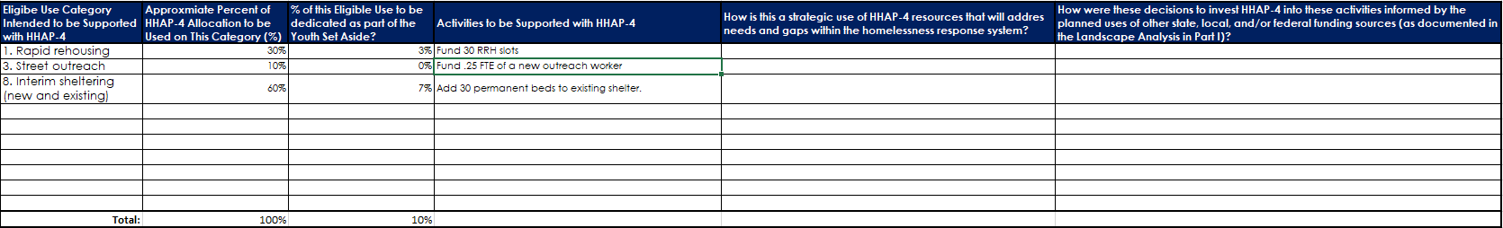

Table 7: Demonstrated Need (EXAMPLE ONLY)
No changes from HHAP-3
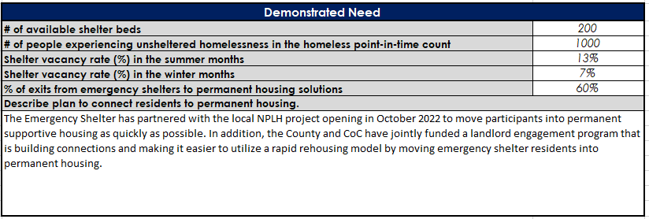
- [50220.8(b)(3)(A)] Please describe how the planned investments of HHAP-4 resources and implementation of the activities to be supported will:
- Help drive progress toward achievement of the Outcome Goals and Goals for Underserved Populations and Populations Disproportionately Impacted by Homelessness (as identified in Part II above).
Click or tap here to enter text.
- Help address racial inequities and other inequities in the jurisdiction’s homelessness response system.
Click or tap here to enter text.
- Be aligned with health and behavioral health care strategies and resources, including resources of local Medi-Cal managed care plans.
Click or tap here to enter text.
- Support increased exits to permanent housing among people experiencing homelessness.
Click or tap here to enter text.

